|  |  |  |
| --- | --- | --- |
| **Anti Slavery International**  **(ASI)** | **Comic Relief: Community Schools for Children of Slave Descent in Niger**  **Comic Relief programme, implemented since 2007 by Anti-Slavery International and Timidria in the department of Tchintabaraden (Tahoua region)** | **Association Timidria (AT)**  ***~AUT0022*** |

**FINAL PROGRAMME EVALUATION**

**Comic Relief: “Community Schools for Children of Slave Descent in Niger”**

**Final**

**By**

**WAFFO Uilrich Inespéré**

**Consultant**

uilrichwaffo@yahoo.fr

**January 2018**

TABLE OF CONTENTS

TABLE OF CONTENTS

LISTS OF FIGURES AND TABLES

ACRONYMS AND ABBREVIATIONS

EXECUTIVE SUMMARY

INTRODUCTION

1. Description of the context of the project

2. Description of the project

3. Objectives and scope of the final evaluation

Objectives of the evaluation

Scope of the evaluation

4. Conceptual framework and methodology of the evaluation

Conceptual framework

Evaluation Process

Ethical considerations

Methodological framework

Data sources and collection techniques

Sampling and Targeting

Data analysis

5. Evaluability, constraints and difficulties encountered

ANSWERS TO THE EVALUATION QUESTIONS

1. RELEVANCE

Consistency of the project with the country's public policies

How well the project met the needs of the beneficiaries

2. EFFECTIVENESS

Results obtained

Consistency of the theory of change

3. EFFICIENCY

4. CHANGES AS A RESULT OF THE PROJECT (EFFECTS)

5. SUSTAINABILITY

V. ORGANISATION AND MONITORING EVALUATION

V.1. Organisation

V.2. Monitoring and evaluation

V.3. Approaches used by Comic Relief:

VII. LESSONS LEARNED FROM INTERVENTIONS

VII.1. Best practices for sustainability

VII.2. Lessons Learned

VII.3. Difficulties and constraints

VII.3.1. Internal factors

VII.3.2. External factors

CONCLUSION AND RECOMMENDATIONS

LIST OF DOCUMENTS CONSULTED

APPENDIXES

APPENDIX 1 Results Chain

APPENDIX 2: Evaluation Matrix

APPENDIX 3 Lists of persons interviewed

APPENDIX 4 Some photos

APPENDIX 5 Terms of References

LIST OF FIGURES AND TABLES

Figure 1: Main stages of the evaluation process………………………………………………………………12

Figure 2: Triangulation and validation process 14

Tableau 1: Structure of the sample 13

ACRONYMS AND ABBREVIATIONS

|  |  |
| --- | --- |
| ASI | Anti-Slavery International |
| AT | Association Timidria |
| CS | Community Schools |
| CR | Comic Relief |
| CSO | Civil Society Organisation |
| DRDPE | Deputy Regional Director of Primary Education |
| ETSP | Education and Training Sector Programme |
| EU | European Union |
| FGD | Focus Group Discussion/Group Discussion |
| ICRC | International Committee of the Red Cross |
| ILO | International Labour Office |
| IOM | International Organisation for Migration |
| LIW | Labour Intensive Work |
| MA | Mothers’ Association |
| MDG | Millennium Development Goals |
| NAPTIP | National Agency for the Prohibition of Trafficking in Persons |
| NEB | National Executive Bureau |
| NGO | Non-Governmental Organisation |
| PA | Parents' Association |
| PAC III | Community Action Programme, 3rd phase |
| PAC/RC | Community Action Programme for Climate Resilience |
| RDPE | Regional Director of Primary Education |
| SDO | Sustainable Development Objectives |
| ToRs | Terms of References |
| USAID | American International Development Agency |
| WFP | World Food Programme |

EXECUTIVE SUMMARY

The evaluation of the second phase of the Comic Relief project: "Community Schools for Children of Slave Descent in Niger" was conducted using an essentially qualitative approach based on the Accelerated Method of Participatory Research. The methodology consisted of a review of the documentation produced on the project and a collection of primary information from the various actors in the field through semi-structured interviews and group discussions (FGD). In the end, about 11 individual interviews and 16 group discussions were conducted for a total of about 120 interviewees. The analysis consisted of a combination of these different data sources according to the content analysis method to extract the informational substance to answer the different evaluation questions. At the end of this work, it was possible to highlight the results below according to the various evaluation criteria selected.

**Relevance:** The project was relevant because it corresponded to Niger's education policy and the willingness of the public authorities to pay particular attention to school enrolment among nomadic peoples. The project was also in line with the needs of the beneficiaries, who initially requested and obtained from the State the authorisation for the creation of the Community Schools (CSs) - although the children themselves have been the users of the services rather than participating in programme design.

**Effectiveness**: The project achieved very good results against the targets. It was also underpinned by a coherent theory of change, although it appeared to be more consistent with the first phase of the project than the second. Given that this second phase was aimed more at strengthening and sustaining the achievements of the first phase, it would have been appropriate to integrate aspects such as health and access to information. Still better, this phase could have replicated the first phase among other communities where slavery still prevails, while maintaining advocacy and awareness in the locations of the first phase. Overall, the main achievements of the project are as follows:

* **Outcome 1: More children of slave descent benefit from the right to quality primary education:** For this outcome, the achievement rate is of 102.92%. The quality of education in CSs has improved and is even considered better than in most government-run schools in the region.
* **Outcome 2: People of slave descent, including children, acquire knowledge and skills to assert their rights:** the number of people of slave descent who took part in the AT's advocacy and awareness-raising activities gives a level of achievement of 117.21% against the target. Meanwhile, the Children's Councils in schools were functional throughout the course of the project and actively involved in the School Management Committees. Therefore, the awareness-raising messages were shown to be put into practice by the beneficiaries.
* **Outcome 3: Families have alternative livelihoods, outside slavery:** 80% of the targeted women (400 women) have benefited from micro-credits with which they have set up income-generating activities (IGA): this gives an achievement level of 80%. A further positive result of this activity is that several beneficiaries now own herds of between 5 and 10 sheep, as well as means of production such as carts. Meanwhile, goat cheese cooperatives are functional in all 6 communities and help women earn an income, enabling them to have a growing influence in the community and in their households and to participate actively in the functioning of the CS.
* **Result 4: Local and national authorities take action to address the needs of communities emerging from slavery:** It appears that the State has become involved with communities of slave descent, having taken full responsibility for the six CSs that were handed over by AT, as well as for the creation of five new schools, and the construction of infrastructure works such as room blocks, wells and boreholes. These actions, however, were taken with the aim not of combating slavery but of fulfilling government functions (such as service provision) more generally. Nevertheless, relations between the authorities and the communities are enduring and cordial. Several other partners also made commitments to provide assistance to these communities at the end of the Tahoua Round Table.

**Efficiency:** The project was overall efficient because all project resources were used appropriately to deliver the project results and were transparently managed. The project also has a good cost-benefit ratio with less than £100 of investment for each person freed from slavery. 78% of the budget was used for direct investments for the beneficiaries, compared to 22% for operating activities, which is well below the 30% generally accepted as an upper limit in financial arrangements.

**Changes brought about by the project (effects):** The project has led to many positive changes in the lives of the beneficiaries, the most significant of which at this stage are: the emancipation of communities of slave descent; the improvement of the school enrolment rate in communities of slave descent; more of authorities’ and development partners’ attention focused on communities of slave descent; women's economic empowerment and poverty reduction in communities of slave descent; people of slave descent becoming gradually more settled; and the reduction of levels of exclusion and stigmatisation of members of the "slave" caste.

**Organisation and monitoring & evaluation:** The project was implemented according to a community-centric, participatory approach, with the involvement of communities in all phases of the project, and a focus on capacity building. The methodology used by ASI and AT consisted in offering services adapted to the socio-economic and cultural contexts of the beneficiary communities, and also in implementing targeted actions to produce global changes. The project also helped resolve the leadership crisis that shook AT between 2011 and 2013.

Monitoring and evaluation of the project have worked well, although its success in producing useful data for decision-making within the project remains mixed. The monitoring and evaluation system for this project was not based on an elaborate and extensively documented method. It was, however, able to produce data that were useful in the preparation of project reports. It is commendable that this system has produced both qualitative and quantitative data. Comic Relief's (CR) partners appreciate its approach as a donor, as it makes their work more efficient: in particular, its flexibility and openness in its procedures and methods.

In its approach, CR goes beyond financial support and looks at the project's progress in the field. Its observations and feedback on the various reports have contributed to improving the quality of the project's results. With regard to its procedures, the annual payment and reporting model allows ASI and AT to plan activities with a more global view and ensure continuity from one quarter to the next.

In the end, the evaluation made it possible to formulate recommendations aimed at sustaining the achievements of the project as a whole, improving ASI and AT's future projects in the region and finally improving the strategy for combating slavery in the area.

**To perpetuate the project's achievements**

* Expand the project to other communities affected by slavery while pursuing awareness-raising activities in the communities targeted by the project;
* Strengthen the support to children who complete their primary school cycle and access secondary education through the provision of partial or full scholarships or even excellence-based scholarships to encourage students to do better in school;
* Refer students from community schools (CSs) to the general education college or vocational training centres, according to their results in the end-of-year examinations and their professional aspirations;
* Help adults (men and women) learn to read and write through literacy programmes, which will enable them to interact easily and independently with the authorities, and above all help their children in their studies;
* Support men in the creation of IGAs so that they too can free themselves from poverty;

**For the improvement of future projects**

* Establish a more effective monitoring and evaluation system through the development of a monitoring and evaluation framework that can provide useful and timely evidence to inform project decision-making. This should include strengthening the capacity of the monitoring and evaluation officer to understand and master this system;
* Ensure that the project’s organigram defines information flow chains and decision-making processes, in order to prevent potential conflicts of competence between stakeholders and bottlenecks in decision-making;

**For the improvement of the strategy to combat slavery**

* Promote access to decent employment and means of production (agricultural land, capital, etc.) for members of communities of slave descent (men and women) in order to enable them to integrate socially;
* Promote access to mass media and information for communities of slave descent in order to enable them to be aware of what is happening in the world and around them, and thus to help them to emancipate themselves;
* Engage in a dialogue with former masters to foster cordial relationships with populations of slave descent;

INTRODUCTION

1. Description of the context of the project

Descent-based slavery (estimated to affect nearly 40,000 people in this sub-Saharan Africa country) is still practiced in isolated areas of northern Niger. Those who emerge from slavery and their descendants are faced with widespread discrimination and have very limited access to sustainable livelihoods and public services. Most of the children of slave descent in these do not have access to education because of the lack of nearby schools and the discriminatory attitudes of the traditional authorities towards communities of slave descent. This leads to widespread under-investment in these regions. Local slave-owners often force these communities to work for free for them. These difficulties are compounded by the semi-nomadic way of life. Child labour is therefore the norm, and girls are very often victims of early marriage (86% of girls in rural Niger marry before the age of 18)[1].

Slavery was criminalised in Niger in 2003, but the law is not properly enforced and there is no policy to address the specific needs of people of slave descent. The on-going efforts of the anti-slavery movement, led by the prominent anti-slavery organisation Timidria, contributed to a better understanding of the problem by the public and the government, and the current President of Niger has formally committed to the eradication of slavery, which creates a more favourable climate for intervention.

1. Description of the project

Since 2007, Anti-Slavery International (ASI) has been working with the Association Timidria (AT) for the eradication of slavery in Niger, through the education of children of slave descent in the department of Tchintabaraden in northern Niger. The initial community school programme funded by Comic Relief (2007-2012) saw the creation of six schools in villages formed by communities of slave descent. Throughout this programme, **340 children of slave ancestry had access to quality primary education, achieving pass rates at the end of year examinations well above the national average**. In addition to establishing schools, **the programme provided micro-credits to 150 mothers and carried out awareness raising sessions on a variety of subjects, including slavery, early marriage, education and health, while facilitating contact between the communities and local, regional and national authorities.**

At the end of the programme, lessons learned from the project (including the recommendations from the final evaluation and consultations with beneficiaries and project stakeholders) fed into the strategy of the second phase which ran from 2013-2017. In addition to continuing to support and expand the capacity of the six community schools, the current programme focuses on:

• Intensifying collaboration between the project and the government to promote the integration of community schools into the formal education system;

• Facilitating and supporting the transition of children to secondary school;

• Promoting more investment by the State in villages formed by people of slave descent, especially with a view to creating new schools;

• Advocacy with multilateral agencies, development organisations and human rights mechanisms to ensure that descent-based slavery is recognised as a priority;

• Conducting awareness-raising and advocacy trainings for communities to encourage their direct engagement with local and national authorities;

• Intensifying efforts to promote child participation through peer support, mentoring and advocacy;

• Strengthening the links between the schools and the communities through Parents’ and Mothers’ Associations;

• Strengthening support for income-generating activities for women as a way to promote communities’ economic independence of.

In parallel, from January 2014 to June 2016, ASI and AT implemented an advocacy project funded by the European Commission, the aim of which was to encourage the State to invest more resources to guarantee access to education and other basic social services among communities of slave descent in the Tahoua region. This 18-month project supplemented the advocacy efforts already undertaken under the community schools programme.

In summary, the overall objective of the CR project is to eradicate slavery in Niger by providing education to the present and future generations of children of slave descent.

The specific outcomes of the programme are:

1. More children of slave descent enjoy the right to quality primary education;
2. People of slave descent, including children, acquire the knowledge and skills to assert their rights;
3. Families have alternative livelihoods outside of slavery;
4. Local and national authorities take steps to address the needs of communities emerging from slavery.
5. Objectives and scope of the final evaluation
6. Objectives of the evaluation

In accordance with the Terms of References (ToR), the overall objective of the evaluation is to examine the extent to which the objectives of the programme have been achieved, to document lessons learned, to examine the changes that the project has brought about, and to make suggestions for future projects.

1. Scope of the evaluation

This evaluation was specifically intended to provide appropriate answers to three main sets of questions:

1. What difference did the project make in people's lives (what, who, where, when)?

2. How did the project make a difference (approaches used by the project and implementing organisations)?

3. Approaches used by CR

Each of these question groups has been divided into a more detailed set of questions so as better to inform the project. Furthermore, in order to keep up with the nomenclature of final evaluations, the questions have been grouped according to the following criteria:

**Relevance**: This is the extent to which the programme objectives match the needs and priorities of the beneficiary population and are consistent with national policies. Relevance will be analysed in a dynamic approach to verify the on-going alignment of the programme objectives with changing national needs and priorities. The alignment of the programme with international agendas (Universal Declaration of Human Rights, MDG, SDO) was also taken into account.

**Effectiveness**: This is the extent to which the programme has achieved the results expected in the project document. It also means assessing the extent to which the beneficiaries targeted by the programme have actually been reached (i.e. to which their lives have been affected).

**Efficiency**: The rational use of resources to achieve results, measured by the extent to which the human, financial and administrative resources employed have been used appropriately to achieve the results.

**Sustainability**: The extent to which beneficiaries have, or are in the process of taking, ownership of the programme so as to ensure continuity of its effects beyond the duration of its implementation.

In addition, the evaluation provides more specific answers to those of the various key questions raised in the ToRs which are not addressed by any of the criteria mentioned above. This includes assessing the project’s monitoring and evaluation system in order to highlight its capacity to generate useful results to guide decision-making within the project.

1. CONCEPTUAL FRAMEWORK AND METHODOLOGY OF THE EVALUATION
2. Conceptual framework

Overall, this evaluation was carried out according to a primarily qualitative approach based on the Accelerated Method of Participatory Research (AMPR). This choice is justified by the fact that this is a community-based project aimed at solving a specific problem within a community. Therefore, the project was designed and implemented using a participatory approach and, it thus seems legitimate that the participatory and community-based approach should be used for the evaluation.

### Evaluation process

The evaluation process followed a four-step approach as outlined in the diagram below:

Figure 1:Main stages of the evaluation process

**Stage 1** consisted of (i) harmonising the views of the consultant and the supervisory team (ASI and AT) on the terms of reference and the conduct of the evaluation; (ii) collecting secondary data through the review of project documentation; and (iii) developing data collection tools.

**Stage 2** consisted of collecting primary data in Niger through in-depth interviews and group discussions with a set of project stakeholders following the sampling done in conjunction with the supervision team. During this stage, the photo and video material was also discussed to make the evaluation more vivid.

**Stage 3** was devoted to compiling the data, analysing and documenting the report, and highlighting the various evaluation results. This "preliminary" report was submitted to the supervisory team for amendment.

**Stage 4** was the final stage during which the amendments made by the supervisory team to the preliminary report were taken into account in an improved version of the final report, which was completed by dissemination tools such as a policy brief and a power point presentation.

### Ethical considerations

For ethical purposes, information was collected on the basis of the respondents' free, informed and prior consent. The objectives of the evaluation and the use to be made of the data collected were explained prior to obtaining this consent. All this was done in strict compliance with the laws governing investigations in Niger, and with Anti-Slavery International's child protection policy[2].

The interviews were conducted in complete confidentiality with women separated from men, children from parents, and political actors (and similar figures) from AT’s members. This allowed the different informants to express themselves freely without constraint.

1. METHODOLOGICAL FRAMEWORK

### Data sources and collection techniques

Two main sources of data were used for this evaluation: secondary sources through the literature review, and primary sources from a field visit.

The literature review consisted of an analysis of all documentation produced as part of the project to extract any information relevant to the evaluation. The information gathered from this review was complemented by field visits to the project sites, during which information was gathered through direct observation, focus group discussions and semi-structured individual interviews. The technique varied according to the information sought and the context. An interpreter was selected for the Tamasheq language interviews in the communities.

### Sampling and target

The collection itself took place at two levels: central and community level. At the central level, information was collected in Niamey (the national capital), Tahoua (regional capital) and Tchintabaraden (department capital) from Niger's education system, and from other authorities and actors involved in the fight against slavery in Niger.

For collection at the community level, a two-level stratified sampling was carried out. At the first level, three of the six beneficiary communities were chosen as a sample. These communities are Intatolène, Inabado and Changhorane. For comparison, two further communities were then also selected which were not being targeted by the project, but were otherwise similar to the three sample communities and had government schools inspired by the CSs created by AT. The communities chosen were Afalolo (2016) and Inamo (2015). The criteria for selecting them communities were mainly accessibility, and school performance as measured by the number of children from these schools who are enrolled in secondary schools.

Five main types of target were sampled during this evaluation:

1. Institutional targets (Niger's education system and anti-slavery actors in Niger)
2. Community targets (notably the traditional and religious leaders of beneficiary communities)
3. Civil society organisations specialised in human rights and education in Niger (NGOs and national and international associations),
4. Project actors such as ASI, AT and CR
5. The beneficiaries (direct and indirect) of interventions.

The list of the different interviewees and their structures, as well as their names, is annexed.

Table 1: sampling structure

| **Target** | **Number of interviews conducted** | **Number of persons concerned** |
| --- | --- | --- |
| Institutional | 5 | 7 |
| Community-based | 3 | 11 |
| Civil Society | 2 | 4 |
| Project actors (ASI, AT and CR) | 6 | 10 |
| Members of the beneficiary communities, including current and former CS students | 11 FGD | 88 |
| Total | 16 one-on-one interviews and 11 FGD | 120 |

In order to comply with this sampling plan, AT served as a coordinator by contacting the various targets to introduce the consultant and by organising the FGDs, where the consultant’s only role was as facilitator.

### Data analysis

The analysis of the collected information used qualitative content analysis techniques. This was the cross-checking of interview data with data from the literature review. The conclusions drawn from these analyses were based on empirical findings submitted to a triangulation process, i.e. a cross-comparison of the three data collection methods described above and a cross-checking of the information obtained from various sources. The diagram below describes this process.

Figure 2: Triangulation and validation process

Document review



T

r

i

an

g

ul

a

tion

e

t

v

al

i

d

a

tio

n

Focus groups

Individual/group interviews

Triangulation and validation

1. EVALUABILITY, CONSTRAINTS AND DIFFICULTIES ENCOUNTERED

The project overall had satisfactory evaluability requirements as all the necessary conditions for the evaluation were met, including documentation and all logistical arrangements. Moreover, the data collected were of good quality to the extent that information saturation[3] was achieved and this information was relevant to the evaluation.

Among the constraints and difficulties encountered were the inability of some respondents to provide information on the period prior to taking up their duties (failure of institutional memory): this was the result of relatively high staff turnover, with no transfer of files at the time of handover. More in-depth interviews with relevant stakeholders and cross-checking were needed to overcome these challenges. At the same time, the sensitive nature of the issue of slavery in Niger sometimes made it difficult to interview the authorities, most of which did not want to address the issue in this way.

ANSWERS TO THE EVALUATION QUESTIONS

1. RELEVANCE

The evaluation made it possible to establish that the project was globally relevant as it was perfectly in line with Niger's Education and Training Sector Programme (ETSP) which is aimed, among other things, at improving the quality and quantity of primary education in Niger. The project is also in line with the Nigerian authorities' willingness to offer schooling methods adapted to populations with specific needs such as nomads. Similarly, the project is in line with Niger's political will to combat slavery in all its forms, as reflected in the inauguration speech by the President of the Republic in 2012.

However, this relevance is somewhat tainted by the fact that the authorities are still reluctant to talk about slavery in Niger and therefore do not see populations of slave descent as having specific needs.

Notwithstanding, the project corresponded perfectly to the aspirations of beneficiaries, who participated both in the identification of the actions to be carried out and the implementation through personal contributions, both in kind (building classrooms, supplying schools with water, construction of transition areas for teachers, etc.) and in cash (12% of the profits from microcredits), with their contributions estimated at about 12% of the project budget.

* 1. Consistency of the project with the country’s public policies
* **Evaluation questions:** Why has the State still not developed programmes or policies that take into account the specific needs of populations of slave descent? What is the nature of the resistance (if any)?

Overall, the evaluation highlighted that the programme, in its schooling component for children, was fully consistent with Niger's school policy. Indeed, in the north of the country, which is lagging behind in terms of schooling, the State has declared a priority education zone and encourages all initiatives aimed at improving the level of schooling in the zone. Thus, the education authorities of Niger in general and of Tchintabaraden in particular have been very supportive of the development and functioning of CSs. This coherence is reflected clearly in the educational authority's statement in the Tahoua region:

“*We are taking any action, whether from NGOs or private individuals, to ensure that all children in Niger are in school. As you know, Niger is one of the most under-educated countries in the world and the ambition of the Nigerien authorities has always been to improve this*”. **Deputy Regional Director of Primary Education in Tahoua**

However, the evaluation found that the strong involvement and commitment of the State in this project is not part of the fight against slavery because for the administrative and even educational authorities of the Tahoua region and in Tchintabaraden, communities of slave descent are not a specific group, which is why the CSs created in these communities cannot be treated differently from other schools in the region. This is justified (on the part of the authorities) by the fact that descent-based slavery is not yet recognised as a government priority.

In the programmes and policies developed by the State, communities of slave descent are not taken into account as a specific and vulnerable group, but are rather categorised as nomadic peoples or populations with little social integration.

This lack of attention to the specific needs of populations of slave descent in Niger's programmes and policies is due to political, economic and socio-cultural resistance:

* In economic terms, there are insufficient resources to meet the specific needs of all groups in its programmes and policies;
* At the political level, descent-based slavery is not recognised as a priority by the Nigerien authorities and populations of slave descent are poorly represented in decision-making bodies (notably Parliament);
* At the socio-cultural level, the social, cultural and political integration of people of slave descent is weak, as they participate little in public life and engage in minimal advocacy with the State;

Above all, the majority of people of slave ancestry live in remote villages and lead a nomadic lifestyle, which makes it difficult to implement programmes targeting these communities.

“*When the State creates infrastructures or implements public policies, it is for everyone, nobody is excluded. However, because of remoteness and other considerations, some communities are still not benefiting. The State also does not have the means to bring infrastructure closer to each community or to make specific projects for this or that community*." **Secretary-General of the Prefecture of Tchintabaraden**.

"*The children of slaves are taken into account in our actions. This is not very visible because they are scattered communities but since the beginning of this year 3 to 4 boreholes have been built in these communities, not counting the wells* ". **Mayor of Tchintabaraden**.

* 1. How well the project met the needs of the beneficiaries
* **Evaluation questions**:

(1) Have the target communities participated in the design, development and implementation of the project besides their participation in awareness-raising and the use of microcredits?

(2) Have the children targeted by the project been involved in the design, development and implementation beyond the mere use of the services available to them? Did the Children's Councils enable children to participate effectively? Are women included in direct advocacy with local and/or regional authorities?

Apart from being mere beneficiaries, the target communities did indeed participate in the development and implementation of the project.

In the design and development phase of the project the project team consulted the communities, noting their expectations and aspirations which were used to refine the project’s theory of change. At the same time, these communities have actively participated in the implementation of the project through the Mothers’ Associations (MA), Parents’ Associations (PA), School Management Committees and goat cheese cooperatives, which were set up and are managed by the communities working independently.

In addition, it might seem as if children were more likely only to be the users of services because they were not really involved in the design of the project. However, they have played a leading role in implementation, through the Children's Councils which operate within schools, actively playing a part in their functioning and their management. In addition, children have repeatedly functioned as "*the channel through which their parents often gain awareness of these issues, which their children often then continue to remind them of so they do not go back to old ways*".[4]

Apart from community facilitators, women from the beneficiary communities were hardly included at all in direct advocacy with local and/or regional authorities.

In Intatolène, the community school was created following a request from members of the community who, with the support of Association Timidria, approached the Nigerien authorities, which then authorised the creation of a school and assigned two civil servant teachers. Two interim teachers were also subsequently recruited. The community contributed to the project by building accommodation for teachers. Community members also help the canteens to run not only by bringing the manpower necessary for cooking meals but also by sometimes providing supplements to enrich the diet (meat, condiments etc.).

Likewise, with the support of AT the communities have successfully carried out advocacy which made it possible to build three classrooms in permanent materials (replacing straw mats which were vulnerable to the weather) and to build a well to alleviate the problem of access to water.

The introduction of a canteen in this school has made it possible to bring more children into the school and keep them there: since 2013, the attendance rate has been steadily increasing and, according to parents, no school-age children living in this community are out of school. Awareness-raising has enabled parents to understand the importance of school and to reorganise community lifestyles so that children stay in villages to continue their studies when parents move with animals to new pastures.

Finally, the bonuses granted to the CS teachers has allowed them to remain in this village under harsh conditions (without hospitals, electricity or drinking water). This has also helped to prevent temporary/contract teachers from dropping out or going on strike because of irregular salaries, as their counterparts in other schools do.

Frame 1 : Case study – CS in the village of Intatolène

Encadré 2 : Etude de cas ECOM du village Indatolen

Encadré 3 : Etude de cas ECOM du village Indatolen

Encadré 4 : Etude de cas ECOM du village Indatolen

II. EFFECTIVENESS

* 1. Results achieved
* **Evaluation Questions**:

(1) To what extent were the project results achieved? Were there any unexpected results? (2) Who has benefited (women, men, girls and boys) and how?

Performance has been analysed here through the indicators of the various intermediate results of the project. The analysis allows us to conclude that the project as a whole is performing well, since most of the targets set at the outset either have now been met or are close to being met. However, this level of performance is not the same for all results so detailed information has been provided for each result.

* **Outcome 1: More children of slave descent enjoy the right to quality primary education:**

For this result, the performance was very good in that, compared to the target of 650 children (equally divided between boys and girls), 669 children, including 341 boys and 328 girls, benefited from primary education at AT community schools over the 2013-2017 period[5], i.e. a 102.92% achievement rate. The higher number of boys among the scholarly population and the earlier marriage of girls explains the predominance of boys among the beneficiaries. The interviews reveal that with regard to schooling, communities do not distinguish between girls and boys. As one mother of a pupil said: "*We do not differentiate between girls and boys in terms of schooling. We are the ones who have asked the authorities for this school, so there is no reason for us not to send our children, girls and boys. If there* *is a child in the community who does not go to school, it is simply because he or she is not yet old enough and if a parent keeps his or her daughter at home instead of sending her to school it is because that parent is stupid.* " **Changhorane village woman**.

As for the quality of education in the CSs, it has improved and is even considered to be better than in most public schools in the region. This is shown in the following remarks made by the Deputy Regional Director for Primary Education (DRDPE) of Tahoua:

"*The advantage of the Timidria schools is that there are enough teaching materials, and teachers seem more motivated and remain in the communities (owing to the bonuses that Timidria gives them in addition to their salaries). It has been reported to me that they sometimes work overtime; and you will find the contractual teachers who are there don't often go on strike when salaries are not paid on time, which means that in these schools the students have more continuity. In fact, I think that if they had electricity in these villages, these schools would be among the best in the country in terms of results, and in the region they are among the best* ".

At the same time, it appears that the quality of training resources has improved in most schools, although the buildings in some CSs are not conducive to the best learning conditions, especially in the rainy season when some schools are forced to stop operating as in Inabado (see photo 1)

Photo 1 : Inabado CS building

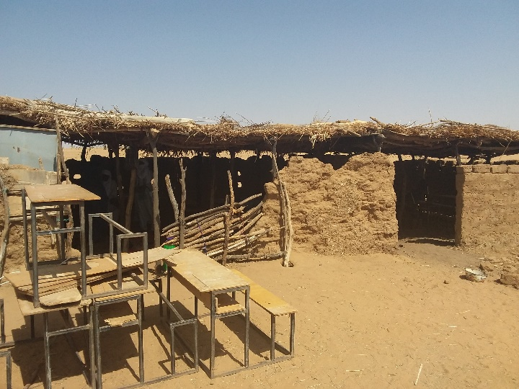

**Source:** field visit

In terms of supporting children's transition to secondary school, performance is mixed. 93 children (31 girls and 62 boys) from AT-supported community schools are at the secondary school in the town of Tchintabaraden, located about 20-40 kilometres from the villages, but many of the children remain there only as a result of the efforts of parents and family members. In 2016, thanks to funding from an organisation called Cultures of Resistance, former students of CSs studying at the secondary school of Tchintabaraden received scholarships in the form of monthly subsistence allowances (CFA 11000/month) and dry goods for students, especially girls. But since then, no further support has been given to these former students.

* **Outcome 2: People of slave descent, including children, acquire the knowledge and skills to assert their rights:**

For this result, performance measured in terms of the number of people of slave descent who took part in AT's awareness-raising and advocacy activities reveals a level of achievement of 117.21%: i.e. 3,692 people (1,772 men and 1,920 women) who had received outreach, against a target value of 3150 people[6]. Here, it is notable that there are more women among the beneficiaries than men.

It was also observed that the Children's Councils in schools were functioning throughout the project and were actively involved in the School Management Committees. In addition, these Councils relayed awareness messages to parents, thus reinforcing their support for the project.

"*Currently, no one can force us to work for him for nothing. Our parents often tell us the stories of slavery: of how people suffered but they accepted this because they were stupid and they had never been to school. But with us, today, this is no longer possible because we know our rights.*" **President of the CS Children's Council in Changhorane.**

On a qualitative level, the beneficiaries were receptive of the awareness-raising messages and put them into practice (especially some of the women, who sometimes spread these ideas to other communities not involved in the project).

"*Everyone here knows their rights, even those who have not taken part in Timidria's awareness-raising activities. Nowadays, every woman in this community knows where to go to complain if she feels disrespected; even if the man of the house always remains the first resort*". **Woman in Intatolène** (FGD).

**Outcome 3: Families have alternative means of livelihood, outside of slavery.**

On a quantitative level, 400 mothers of pupils out of the target of 500 have benefited from microcredit and support in setting up IGAs, i.e. an achievement level of 80%. The IGAs have contributed to the socio-economic empowerment of women in communities of slave descent and have helped to free them from slavery within the household where they were sometimes subordinated to men, often because they did not have access to a means of production. Thus, the evaluation found that micro-credits granted to women allowed them to develop economically in the sense that many of them became owners of herds of between 5 and 10 sheep, and even of means of production such as carts and others.

***5:Case study - participation of the children's council in Inazgar***

In Inazgar, after a meeting, the Children’s Council questioned the parents on their responsibilities towards their schooling while reminding them of their rights and obligations as parents. This led to parents providing a permanent water supply for the school, and more involvement of parents in cooking canteen meals.

"*Before, we had nothing. A woman couldn't even talk about having her own money; at the most, we might go on long journeys to get straw for making mats. But when Timidria taught us how we could set up a paying job using only a small sum of money, we very quickly became involved and each one of us now carries out a small activity that allows us to earn money. With this money, we help our husbands with household expenses and also we send our children to Tchinta*". **A woman from FGD Intatolène**.

In addition, goat cheese cooperatives are functional in all 6 communities and demonstrate the participation of more women. Despite the low profitability of this activity, these cooperatives offer ways for women actively to participate in community life and to support the functioning of CSs.

"*The co-operative works well and it doesn't just benefit women because even men benefit. That's why they even help us in some jobs like grazing the animals because the little money it brings in allows the family to live*.” **Female member of the Inabado Cooperative**.

* **Outcome 4: Local and national authorities take action to address the needs of communities emerging from slavery**

In this respect, it is clear that the State has been involved with communities of slave descent: firstly through taking up full responsibility for running the six CSs handed over by AT (including teachers' salaries, textbooks, canteens, etc.); and secondly through setting up and building schools schools in the slave-descended communities of Inamo, Jugui Agoda, Ineiss, Infriji and Afalolo. At the same time, the 6 CSs benefited from some investments such as

* Drilling of wells (Changhorane and Tanguézatane);
* Classroom blocks (Intatolène and Changhorane);
* Three wells (Inabado);
* Economic development programmes through cereal banks (Inazgar), livestock food banks (Inazgar and Dalloussaye), and cash for work programmes (Inazgar, Changhorane, Inabado, Intatolène anf Tanguézatane).

However, it should be noted that the actions of local and national authorities are not undertaken specifically as part of the fight against slavery but rather in the context of implementing standard government functions such as providing basic services, as suggested by an administrative official in Tchintabaraden: "*public services are accessible to all without discrimination of any kind. And for the communities you're referring to, they gather in villages and have chiefs who serve as representatives of the authorities for those communities. We consult these leaders very often in decision-making.”*

Photo 2: Improvement of learning conditions in Intatolène school as a result of AT-supported advocacy

**After**

**Before**

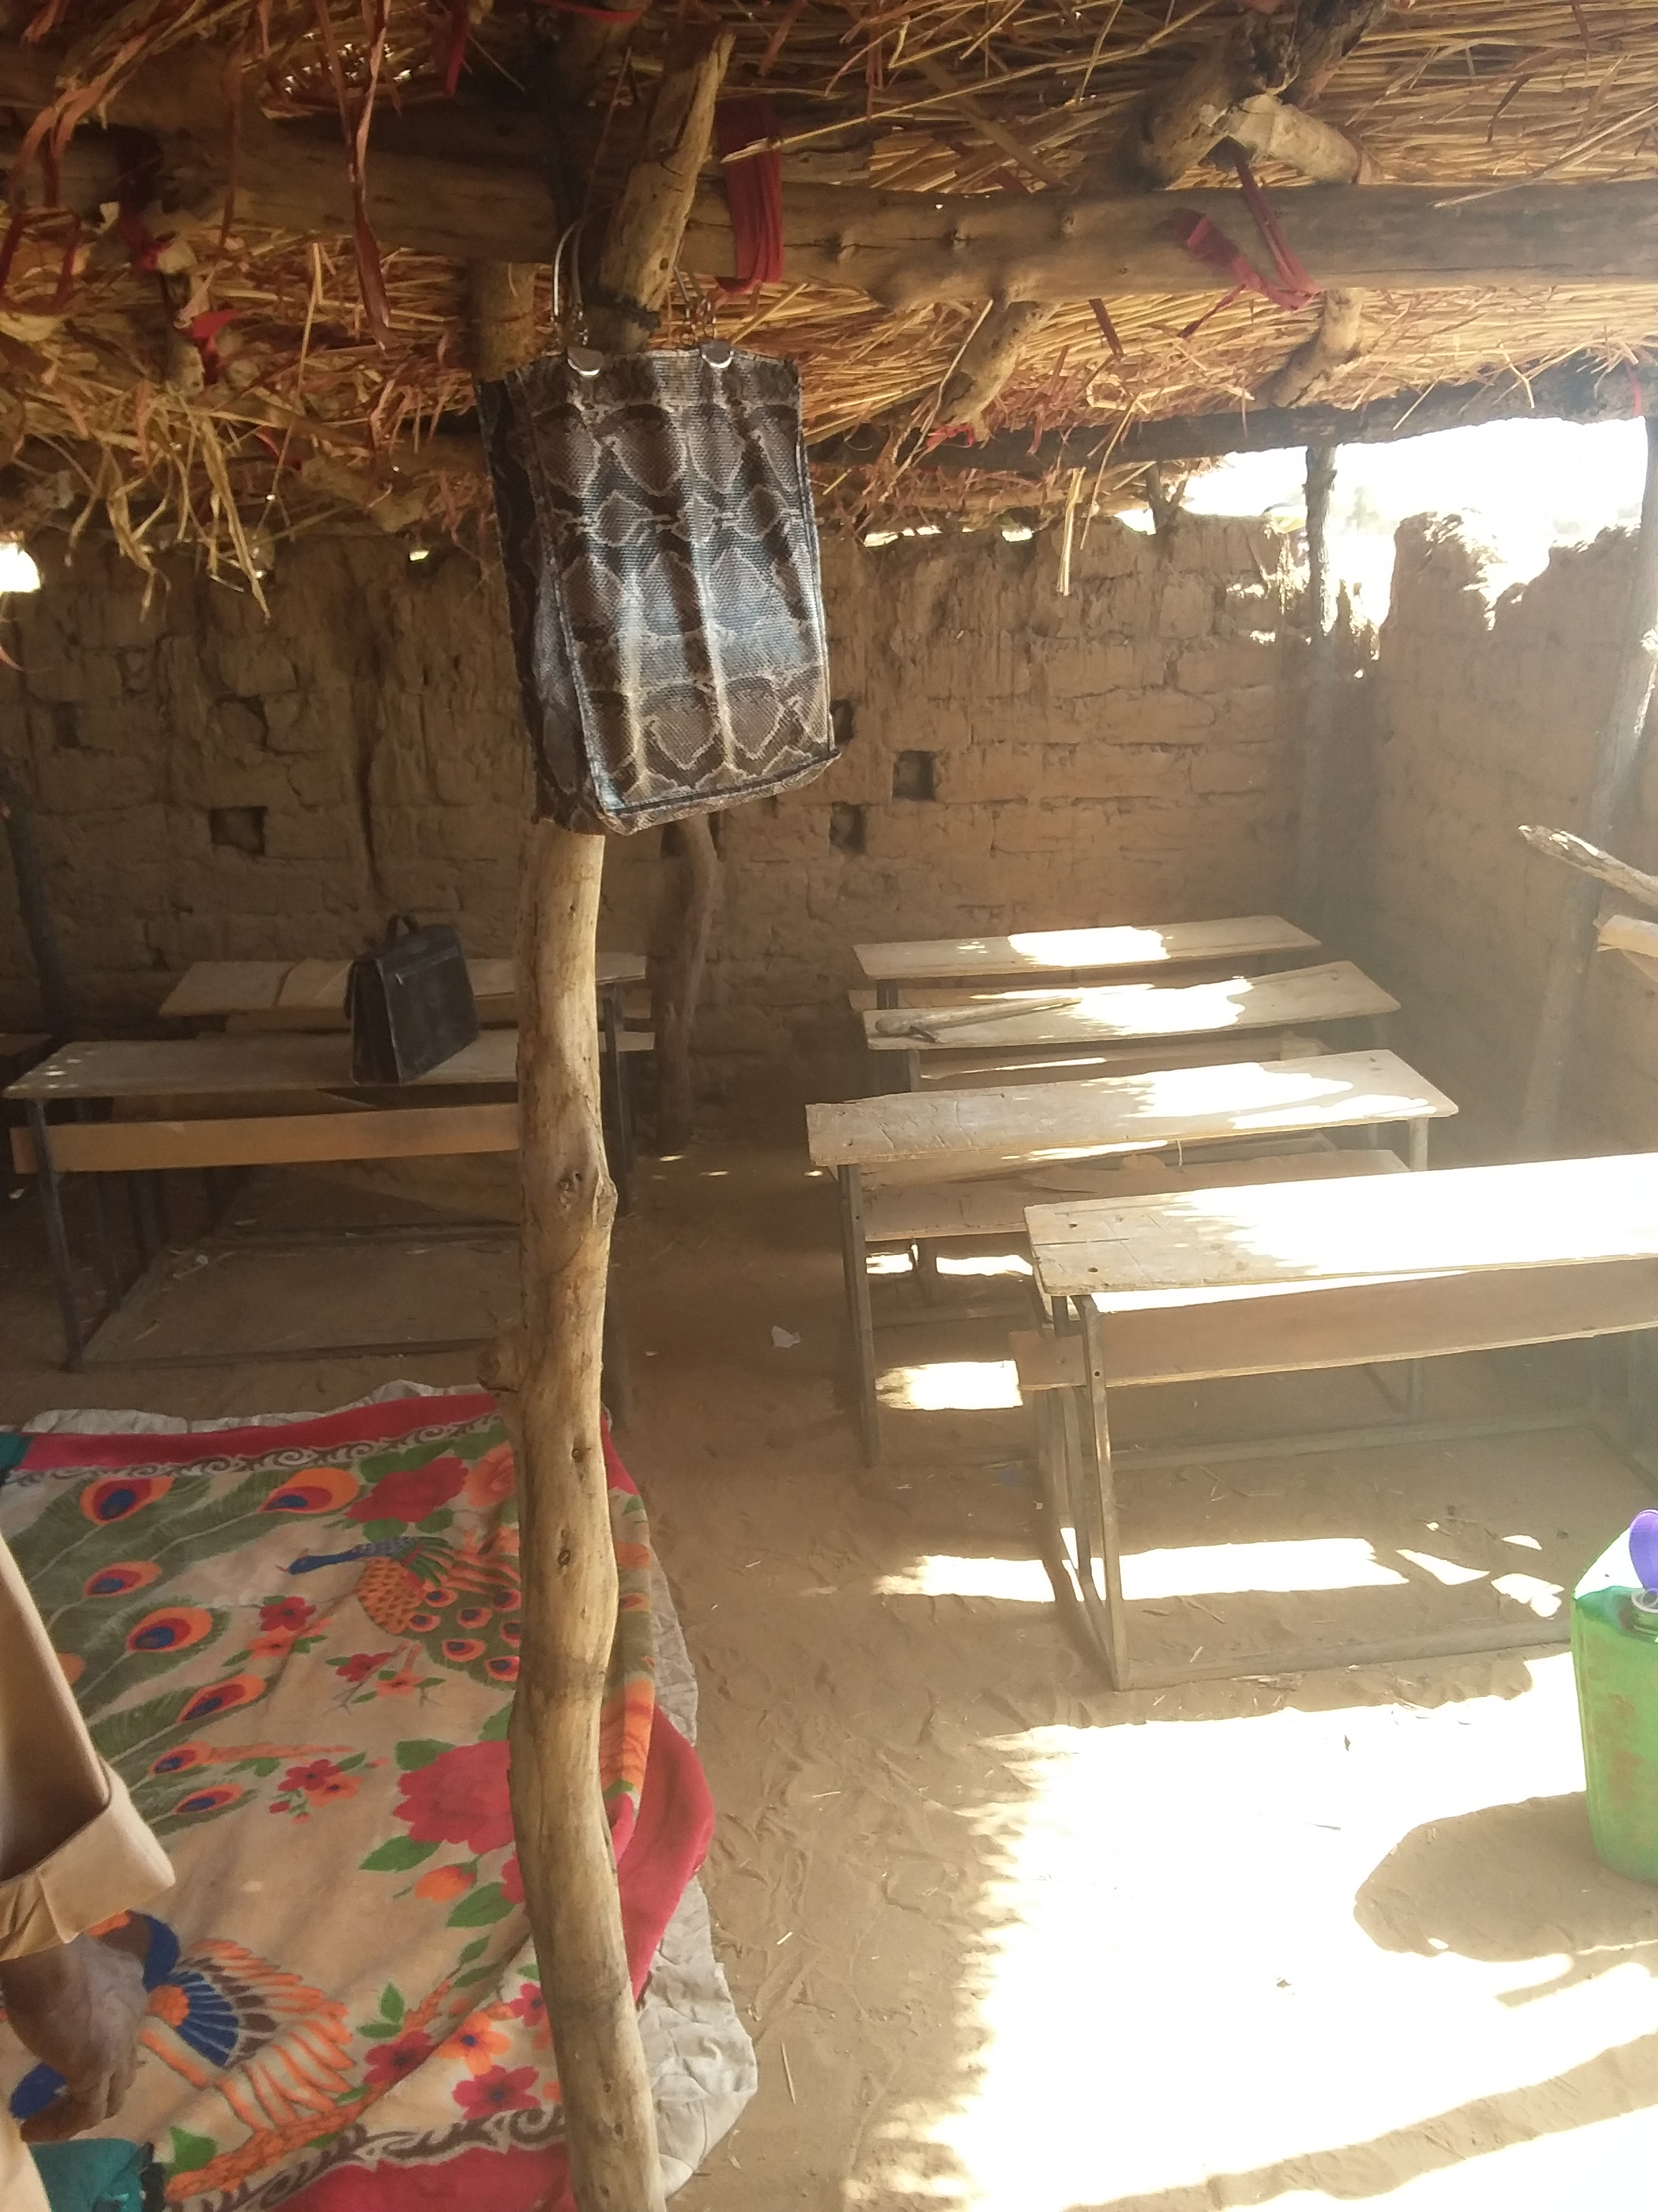Avant

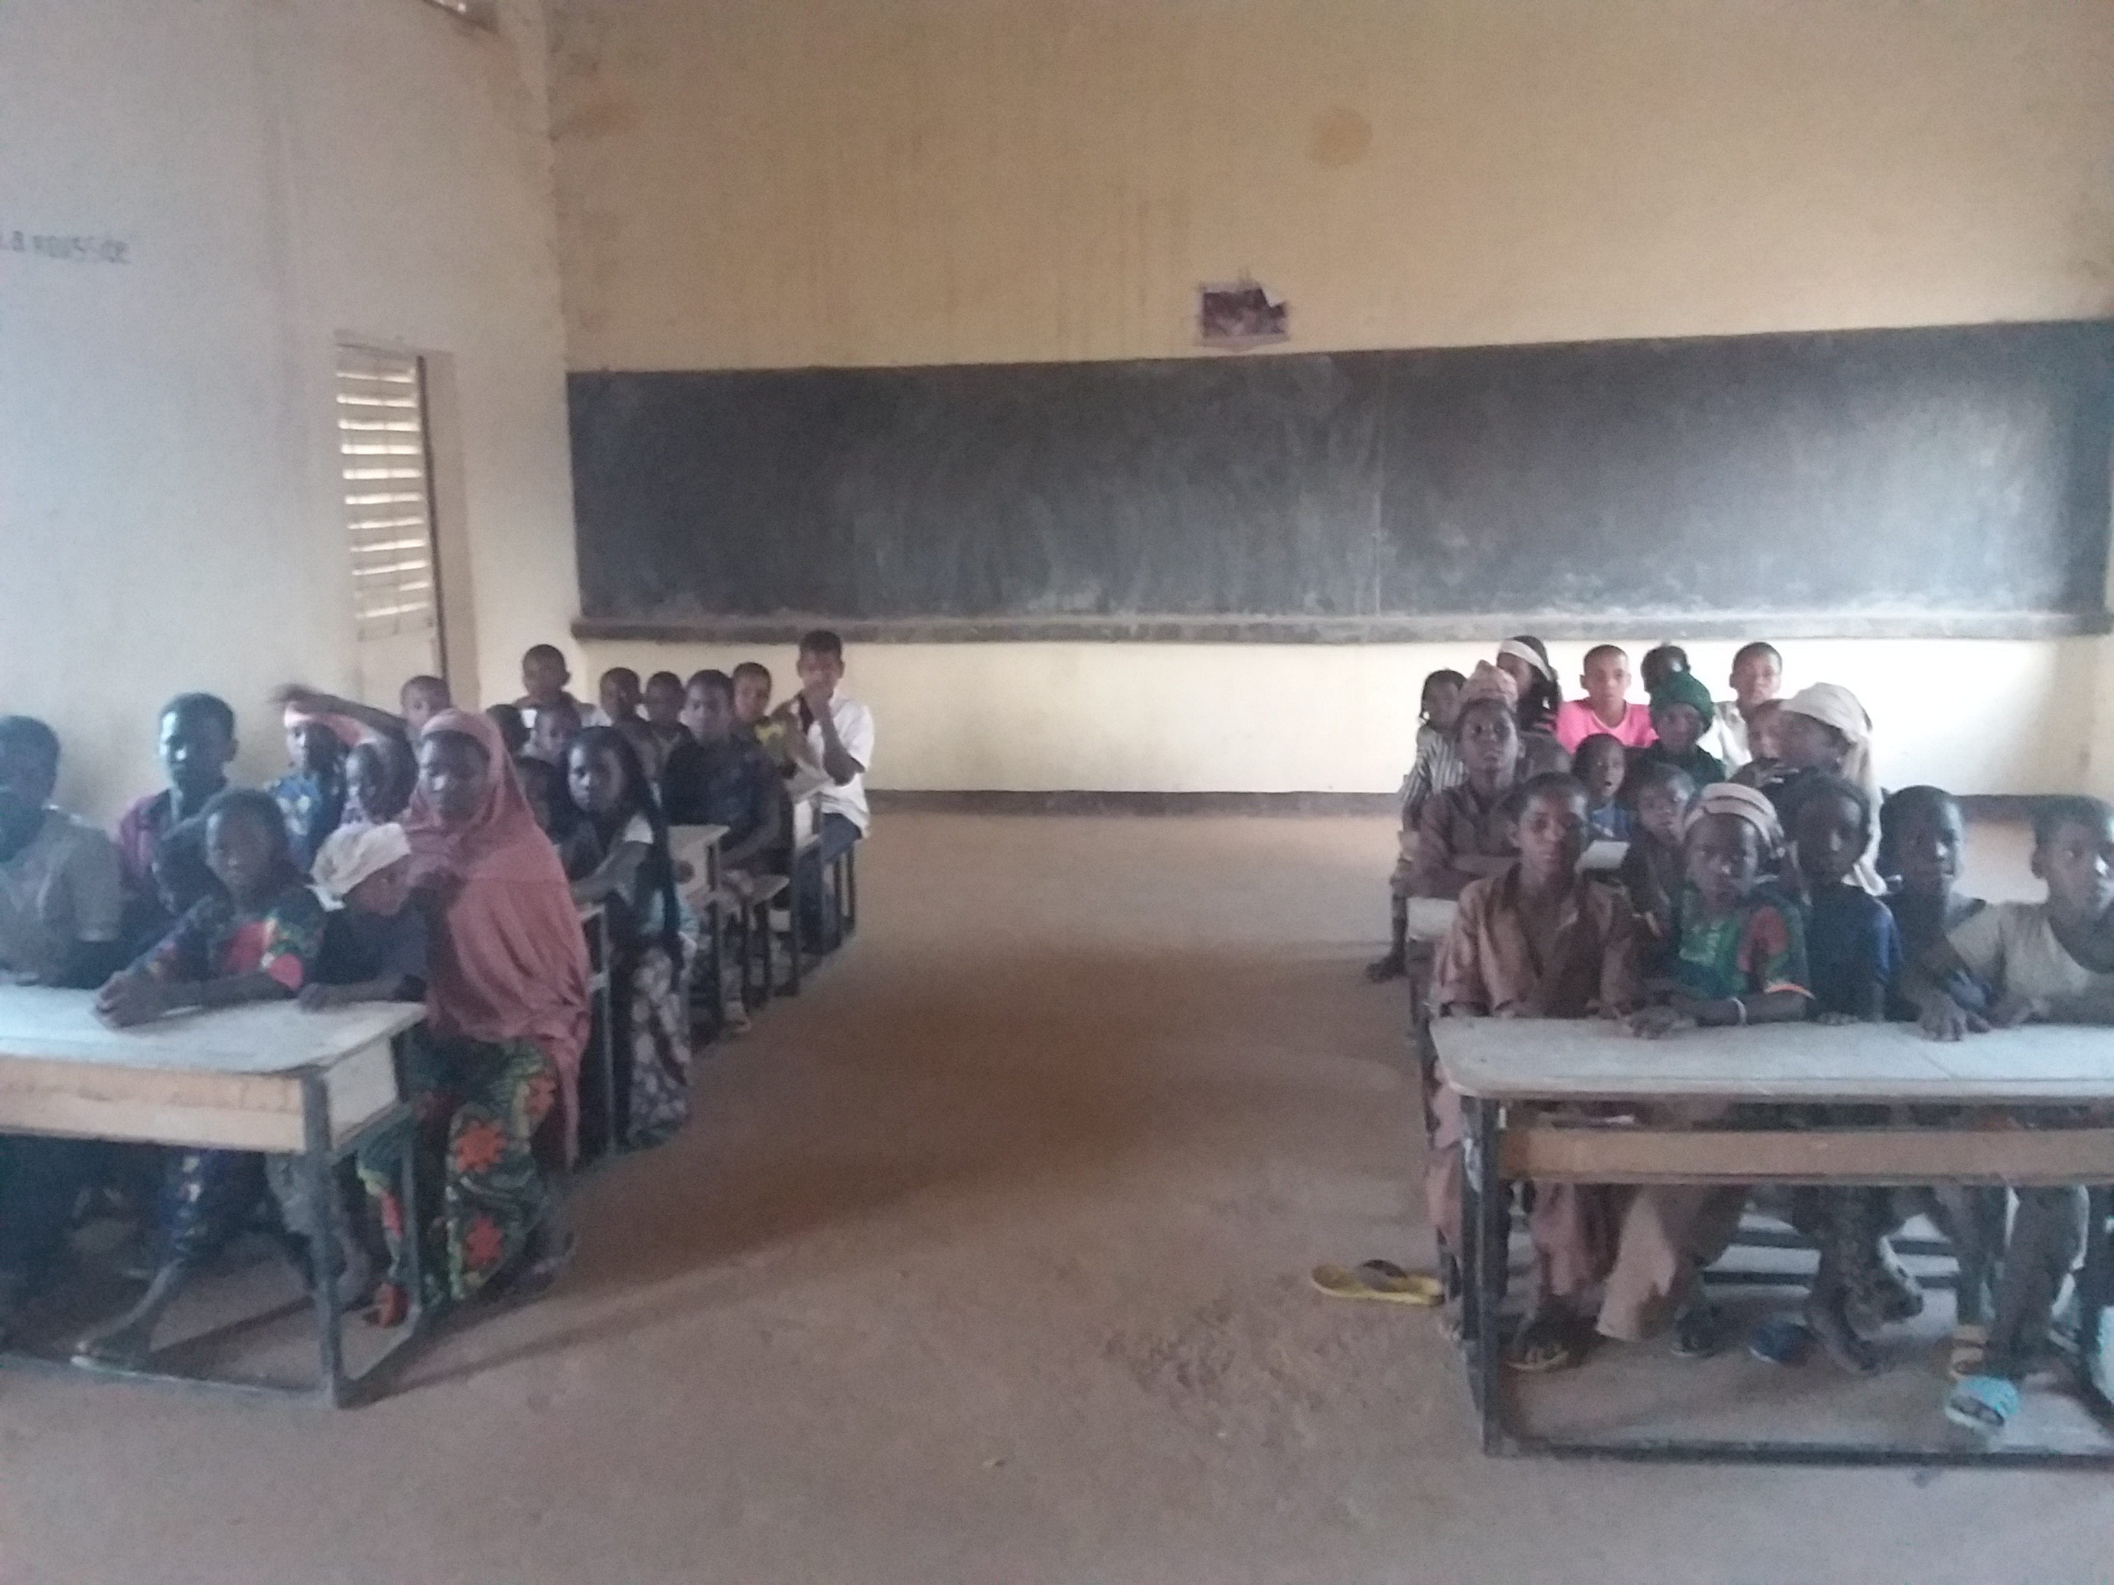

In addition, it was possible to observe permanent contact and cordial relations between the communities of slave descent and the authorities of the department of Tchintabaraden. Indeed, interviews and observations carried out in the field give the impression that community members have developed a closer relationship to the authorities than they had in the past for expressing demands and grievances. These demands and grievances lead to results wherever it is possible, as can be seen from this statement made by a chief of slave descent:

"*Before we didn't know that the authorities in Tchinta were there for us; we thought that they were there only for the elite. But now it's no longer the case. Myself, I go to Tchinta to meet the Mayor and the Prefect whenever I want and they receive me with respect. I tell them about the grievances of our community and they sometimes come up with solutions such as, for example, the construction of the well. Even those who aren't bosses like me go to the authorities when they're in trouble. For example, my brother here went to court to complain against one of these former masters who wanted to take away his land. In the end, justice proved him right. Here we were so happy and now we encourage our brothers from other villages to do the same*." **Inabado village chief.**

At the same time, in addition to the State, several other development partners have engaged with communities of slave descent by implementing projects:

* The International Organisation for Migration (IOM) has initiated a socio-economic reintegration project in two villages of slave descent, providing small grants to foster IGAs;
* The International Committee of the Red Cross (ICRC) has made a mini borehole in Tanguezatane;
* Support for advocacy actions, and facilitation of contact with UN agencies, by the International Labour Office (ILO). The ILO has also provided financial support to the Niamey Round Table on implementation of the Tahoua Round Table commitments and the search for new partners, with a view to securing more concrete commitments;
* The U. S. Agency for International Development (USAID) has supported capacity building and community awareness-raising;

These commitments by development partners were among the most important outcomes of the Tahoua Round Table in 2015.

* 1. Consistency of the theory of change

**Evaluation Question:** What was the overall theory of change of this project? Were there limitations or inadequacies?

The theory of change of the project, as outlined in the appendix, is enrolling more children from communities of slave descent in school while economically empowering the members of these communities, creating contacts between these communities and the authorities, and sensitising them on slavery practices, early marriages, etc. will lead to the eradication of slavery in Niger.

The analysis concludes that this theory of change is very coherent. It is inclusive and addresses the problem in all its aspects. It also shows a good analysis of the cause-effect relationships between the different aspects of the problem and suggests appropriate solutions to address these aspects.

However, this theory of change is more suited to the first phase of the project (2007-2012) than this second phase (2013-2017). The activities in this phase of the project have been directed towards the same communities that benefited from the first phase (2007-2012): they seem aimed more at reinforcing the achievements of the first phase rather than broadening the spectrum of action towards new communities where slavery still exists.

Furthermore, it was observed that, to be more comprehensive, this theory of change could have incorporated aspects such as health and access to information for populations of slave descent. This is true to the extent that these other strands are also crucial to achieving the desired change: because better health and access to information for the target population will certainly contribute to reducing its marginalisation and stigmatisation, and to freeing it from the yoke of slavery (insofar as slavery practices persist because of psychological and cultural resistance).

1. EFFECTIVENESS

* **Evaluation questions**:

(1) To what extent have the project's management and financial systems been effective (planning, forecasting, budgeting, coordination, communications, reporting, filing of receipts, etc.)? Did they contribute to or hinder the achievement of change?

(2) Did the project have a good cost-effectiveness ratio? To what extent did the project optimise resources (human, material and financial)?

Analyses reveal that all project resources were used appropriately to achieve the project results. The project also has a good cost-benefit ratio, costing less than £100 of investment per a person freed from slavery[7]. 78% of the budget was used for direct investments to beneficiaries, compared to 22% reserved for operating activities, which is well below the 30% generally tolerated in financial arrangements. This leads to the conclusion that the project was very efficient.

Furthermore, it was found that the management of project resources was carried out in a transparent manner, insofar as this management was based on the AT Procedural Manual which complies with the requirements of the Organisation for the Harmonisation of Business Law in Africa (OHADA). The AT Procedural Manual subjected disbursements to rigorous controls and ensures expenditure is supported by full documentation. However, the inflexibility of this budgetary management has sometimes created a bottleneck for the timely implementation of activities.

1. CHANGES AS A RESULT OF THE PROJECT (EFFECTS)

Evaluation Question:

(1) Are these changes relevant to the needs of the beneficiaries?

(2) To what extent has the project contributed to the implementation or adoption of national and international policies, conventions etc. in the country where the project is implemented?

(3) Have there been changes in policies, practices and attitudes among politicians and decision makers that have benefited the target groups?

(4) To what extent does the State now recognise the existence of communities of slave descent as a "separate" group with special needs?

(5) To what extent has the project reduced the levels of exclusion and stigmatisation of members of the slave caste?

In accordance with its theory of change, the project has brought about many positive changes to the lives of communities of slave descent, including in domains outside the project’s specific aims. As the project is relatively new, its medium and long-term effects are not discernible at this stage. Nevertheless, several significant changes can be highlighted during this evaluation:

**- The emancipation of communities of slave descent**: as a positive result of the project, the myth of the hierarchy between classes is gradually being discredited in most communities of slave descent, especially among school children who are more aware than their parents and do not consider themselves inferior to anyone else. Members of communities of slave descent also have higher self-esteem and no longer feel stigmatised by other communities. This change has fostered increasingly close contact between these communities and the authorities, due in part to the election of a person of slave descent as Mayor of Tchintabaraden and the appointment of AT's former Advocacy Focal Point as Prefect of Tchintabaraden. This emancipation of communities can be seen in the statements below:

"*Today, we don't consider ourselves inferior to anyone else, and one thing is certain with the effect the school has had on our children: no one in this community will ever experience slavery again*". **Changhorane men's FGD**

"*As far as I'm concerned, no one can force me to get married if I don't want to. It used to be possible because girls didn't know their rights. Today, however, most of us here dream of becoming an important person in this country. Our parents understood this thanks to the awareness-raising efforts of Timidria, and today it is our parents who want us to go as far as possible at school*". **FGD secondary school student (and former CS student) in Tchintabaraden.**

"*Before, no one here among us could even look at anyone in the noble class face to face. But today, everyone has understood that we have the same rights and that they are not superior to us. Some of us even denounce these former masters to the authorities when they are trying to break the law*." **Men’s FGD Intatolene.**

"*If anyone here wants to be superior to us, it's too bad for him because we know from what we've been taught that we're all equal. Even if our parents have been abused, it will never be the same for us because we have been taught that we are all equal and if you do well at school, you can be a very important person tomorrow and even be the person giving instructions to people who believe they are from a higher social class*". **Member of the Inabado Children's Council.**

**- Improving the school enrolment rate in communities of slave descent:** Thanks to the project's achievements, more children of slave descent were educated in communities where AT intervened than in neighbouring communities. Indeed, in villages where AT has intervened, all school-age children are systematically sent to school and dropout rates are very low or non-existent in most of these communities. This situation has affected many of the surrounding communities near those where AT intervenes, and many children are now sent to school there too. This change is due in particular to the active involvement of communities in the schooling of children with direct support (secondary education provision) and indirect support (participation in school operations) through the PAs and MAs. The statements below further illustrate this change:

"*Before, we didn't know the importance of school. But since Timidria brought us this school, and with the awareness messages, we have understood that the survival of our community depends on our children's schooling. This is why any child of school age is systematically sent to school even without their parents being asked. If our parents had also acted like that with us it would have saved us a lot of problems, including servitude*." **Man FGD Inabado**.

**- More attention to communities of slave descent on the part of public authorities and development partners**: This is one of the effects of the advocacy campaign carried out with the support of the European Union, culminating in the Tahoua Round Table at the end of which many actors made firm commitments to take more measures to assist people of slave descent.

**- Women's economic empowerment and poverty reduction in communities of slave descent**: Thanks to the micro-credit granted to women (and the support they have received for the implementation of IGAs such as the manufacture of animal fodder, handicrafts and sheep herds), women have become active in the goat cheese cooperatives, which they operate independently. Income from these various activities has enabled women to become economically empowered and to improve their status in their communities by contributing to household expenses and gaining more recognition by men. This effect is illustrated through the statements below:

"*Due to the small activities we carry out, we no longer feel obliged to go to our husbands for the slightest need. And when, in the past, that was the case, we were like children in front of them, especially for those who are polygamous. The little that the husband had, he must share between all his wives, and in the end we ended up with almost nothing. Today it is rather we who help our husbands, sometimes even by lending them money. Since we have been involved in these activities, we feel more respected by men and also we feel more useful to the community.*" **Femme FGD Intatolène.**

"*I used to depend entirely on my husband, who didn't even have anything. Today I'm the one who takes care of almost all the household expenses thanks to the income I get from the animal fodder I make and sell at the market. And all this is thanks to the microcredits and the various training courses we received on women's leadership*." **Changhorane Women’s** **FGD**

**- The gradual sedentarisation of people of slave ancestry**: The schooling of children and the IGAs adopted by women require populations of slave descent to leave their traditional nomadic way of life for a settled one. This progressive sedentarisation manifests itself through briefer periods of transhumance (moving to new pastures), and the fact that this transhumance is no longer practiced by all members of the family.

- Reducing levels of exclusion and stigmatisation for members of the slave caste: the evaluation has shown that public programmes and policies in the Tahoua region now take greater account of the specific needs of nomadic populations in the region, which include communities of slave descent. Although the government recognises that slavery continues in certain parts of Niger, it does not see communities of slave descent as constituting a distinct group with its own needs other than as a part of nomadic populations.

*“We report our problems directly to the Mayor or to the Prefect at Tchintabaraden. Since we started doing this, we have benefited from increasing numbers of initiatives such as these classrooms, or the drilling work (without which we would perhaps all have died). Before, we didn’t even know we mattered enough for the government to do this for us.* **Intatolène village chief.**

1. SUSTAINABILITY

* **Evaluation questions:**

(1) Is it likely that these changes will be sustainable in the long term?

(2) To what extent is the direct dialogue initiated between communities and authorities sustainable, and can it bypass the intermediary role of AT?

(3) Is there a risk of returning to slavery or exploitative practices for the beneficiary communities, or is the level of emancipation such that this risk is now minimal?

The changes brought about by the project are sustainable in the long term insofar as the direct beneficiaries (communities of slave descent) and indirect beneficiaries (the State) have taken ownership of the project and have been involved in its conception and implementation. The project is also politically, economically and culturally viable. This implies that it can be replicated in several communities. More specifically, the handover of schools to the State, and the commitments made by the State and its partners at the Tahoua Round Table, are proof of the sustainability of these schools. Moreover, the canteens of the Timidria schools were registered with the government’s top group of school canteens, the Quality Education Support Project (PAEC)[8].

With regard to microcredits, the level of repayment is satisfactory, but the fact that no constraint mechanism is put in place to prevent repayment defaults has a disadvantage in terms of sustainability.

As far as goat cheese cooperatives are concerned, the autonomy of beneficiaries in their management and the increase in their production are a guarantee of sustainability. However, the absence of a mechanism to prevent and anticipate risks may constitute a handicap. Indeed, these cooperatives are highly exposed to climate-related risks and epizootic diseases that affect their functioning.

The dialogue initiated between the authorities and the communities is sustainable insofar as the senior authorities of the department are of slave descent and/or share the ideals of Timidria (as in the case of the Mayor and the Prefect). The communities are also convinced that the authorities are there to help, and approach them with problems which the authorities, in turn, address. Therefore, it seems certain that this dialogue can continue without the intermediary role of AT, but can only happen in the medium term and if awareness-raising activity continues.

Finally, it appears that the level of emancipation of the beneficiary communities is such that the risk of returning to slavery or exploitative practices is minimal, if not non-existent, because having experienced freedom the beneficiaries will simply not accept a return to slavery. Beneficiaries at all levels (parents, children, women) agree that a return to slavery is impossible for them and express sympathy for communities that "still allow themselves to be enslaved".[9]

1. ORGANISATION AND MONITORING EVALUATION
   1. Organisation

**Evaluation questions**:

(1) What were the most effective methodologies and approaches used by Anti-Slavery and Timidria to drive change in people's lives? What worked and what didn't?

(2) How has the relationship between partners (local and national Timidria offices’ relationship between themselves, and with Anti-Slavery) aided or hindered the achievement of change/results?

The project was implemented using a community-based and participatory approach, with the involvement of communities in all phases of the project and using capacity building to increase their participation. The methodology used by ASI and AT consisted in offering services adapted to the socio-economic and cultural contexts of the beneficiary communities, and also in implementing targeted actions to produce broader changes. ASI and AT also took advantage of the flaws in the government’s current approach to move the project forward in the desired direction. For example, during the advocacy phase, they sometimes talked about vulnerable nomadic populations instead of populations of slave descent in order to convince the authorities to commit themselves to supporting these communities. This coordination was also achieved by bringing together decision-making and evidence from the field through the local AT office, which was responsible for implementing the activities in the field.

The project benefited greatly from the cordial and complementary relationship between AT and ASI in that the two organisations worked together on friendly terms in pursuit of the project's objectives. The strength of this collaboration lies in the openness of dialogue and strong internal communications, with all necessary information freely available to actors at each point in the decision-making chain.

Finally, the leadership crisis in AT at the beginning of the project could have adversely affected the project by causing a delay in start-up and a freeze of activities. However, the resolution of this crisis through ASI's organisational coaching, as well as Comic Relief's understanding and support through the provision of a capacity building budget, were very beneficial and helped prevent this crisis from affecting the project.

* 1. Monitoring and Evaluation
* **Evaluation questions**: To what extent have the project's monitoring, evaluation and learning systems been effective (validity and reliability of data collection, data quality, classification and analysis, effectiveness of processes in place for information use and sharing)? Did they contribute to or hinder change?

Monitoring and evaluation of the project has worked well, although its success at producing data that are useful for decision-making within the project remains mixed. The monitoring and evaluation of this project was not based on an complex, thoroughly documented system. Nevertheless, it still produced data that were used to develop the project reports. Furthermore, the fact that this system is based on both quantitative and qualitative data is commendable.

However, while the overall quality of quantitative data is very good, qualitative data are not always of high quality and often lack precision owing to the absence of new information in each year’s collections. Collection was not made regularly and was not based on standardised tools (notably because of the absence of a documented monitoring and evaluation framework), and this undermined the credibility of these data and therefore the relevance of the analyses which they were used to make.

The evaluation of the project reports shows that these data have been used extensively to monitor progress towards the results while identifying bottlenecks and changes in the lives of beneficiaries across the process. However, it appears that the qualitative data used were limited to the comments of those beneficiaries who were in favour of the project, whereas it was more of a priority for them to provide information on what was not working and on problems in implementation.

* 1. Approaches used by Comic Relief
* **Evaluation questions**:
* (1) How have Comic Relief's grant allocation policies and processes (e.g. defining strategies and programmes, method of evaluating project proposals, etc.) helped or hindered the achievement of sustainable change?
* (2) How has Comic Relief's approach to grant management (e.g. individual work with grant recipients, and learning activities with other funded organisations) helped or hindered sustainable change?
* (3) How has Comic Relief's use of its organisational strengths (e.g., media use, access to decision makers) helped or hindered sustainable change?

(4) Are there other ways in which CR has helped or hindered the achievement of change?

Comic Relief, as the main funder of the project, uses an approach that suits the partners (ASI and AT), as it allows them to work effectively. For ASI, CR "*is a donor with whom it is a pleasure to work because CR always provides very relevant and enthusiastic feedback on the annual reports we send*".[10]. CR appears to be a flexible and open donor in its procedures and methods.

In its approach, CR goes beyond financial support and pays attention to the development of the project in the field. CR appreciates that the focus of project reports is not solely on what is going well, and encourages it also to include challenges and difficulties. Meanwhile, CR's observations and feedback on the reports contributed to improving the quality of project results. Thanks to CR showing interest in how the project addressed issues such as early marriage, for example, the project team placed more emphasis on these issues during its implementation, which led to more positive impact on the lives of beneficiaries. Similarly, CR's insistence on the importance of illustrating changes through testimonials or case studies has greatly contributed to improving ASI's communication work, insofar as *"case studies enable us to communicate more humanely about the work we are doing in Niger".[11]*

With regard to its procedures, Anti-Slavery and Timidria greatly appreciated the annual payment and reporting model as it allows them to plan activities on a more strategic level and better to ensure continuity from one quarter to the next. Similarly, allowing the project to use the under-utilisation of one year's budget the following year was a real asset for the project, as it made it possible to top up certain lines that had been under-budgeted such as capacity building for staff.

However, CR's switch to biannual transfers with a reporting requirement every six months is likely to hinder implementation of the project because, according to ASI, "*this may hamper the organisations implementing the project on the ground because there is always a ’gap’ between the time the annual report is submitted and the time the donor makes the transfer. It is this gap that could adversely affect the quality of the implementation of projects."*

1. LESSONS LEARNED FROM INTERVENTIONS
   1. Best practices for sustainability

* Reinforcement of AT’s technical and organisational capacities by ASI and especially the mediation of ASI to resolve the organisational crisis that took place within AT;
* The sharing of information in real time between the project’s different actors (local office and National Executive Bureau of AT, ASI, CR etc.);
* ASI's regular monitoring missions in the field in Niger;
* The establishment of a monitoring and evaluation system to produce both quantitative and qualitative data to support decision-making;
* Mobilisation of additional resources to extend and/or strengthen project activities (EU for advocacy, Cultures of Resistance for the bursary to middle school students);
* Active involvement of the beneficiaries in all phases of the project;
* The format of the CR annual reports which are short, very clear and easy to read;
* The active involvement of CR, which went beyond simply providing funds and also sent detailed feedback after receiving the annual reports. This was a real asset for the project;
* Baseline study on the needs of the communities of slave descent in Tchintabaraden, which was important for the development of effective strategies;
* Strong collaboration between the project team and local and national authorities, and the sharing of experience with other civil society organisations working in the same field.
  1. Lessons learned
* Community mobilisation and local awareness-raising are effective ways of inducing behavioural change in self-sufficient communities such as communities of slave descent in the Tchintabaraden zone of Niger;
* School canteens are essential for children’s schooling and for their retention in schools, both in nomadic areas in general, and specifically in communities of slave descent;
* The emergence of role models from populations of slave descent who have achieved social success (such as the Mayor of Tchintabaraden) has been a determining factor in reducing the social and cultural obstacles to schooling among nomadic peoples in general, and within communities of slave descent in particular, by making awareness-raising messages more credible to these populations;
* The flexibility of CR’s administrative and financial procedures has facilitated collaboration with ASI and made ASI and AT more independent in project management and implementation;
* Timidria's strong influence with the Nigerien authorities and its considerable capacity for mobilisation have contributed to effective advocacy towards the State and development partners.
* Education is a very effective means of combating slavery and the social and economic marginalisation of vulnerable communities, especially given how slavery in the Tchintabaraden region is also psychological and is rooted in communities’ economic precarity;
* Involvement of parents and students in school management committees (COGES) is important for their participation in running the school.
  1. Difficulties and constraints
     1. Internal factors
* The desire of AT’s National Executive Board to become too involved in the management of the project, rather than limiting itself to strategic decisions as provided for in AT’s statutes, has caused some friction with the project team, which has sometimes harmed the project;
* The facilitators and the Monitoring and Evaluation Officer have faced challenges in travelling to project destinations, sometimes having to walk tens of kilometres to reach communities;
* The rigidity of the indirect cost line in the budget, which did not allow for the management of unforeseen circumstances;
* The allocation of insufficient amounts to micro-credit have limited women's initiatives.
  + 1. External factors
* Climatic conditions have led to water shortages in schools, thus preventing canteens from operating (during long droughts), and caused the destruction of classrooms in some schools (during heavy rain showers);
* The resurgence of certain epizootic diseases such as rift valley fever has decimated many of the animal herds that women had acquired through micro-credit, and has also negatively affected the functioning of goat cheese cooperatives;
* The manipulation of religion, especially by certain sects aiming to perpetuate slavery practices, can give rise to doubt among some people freed from slavery as to their status and rights.

CONCLUSION AND RECOMMENDATIONS

It is clear from the analyses made above that the second phase of the Comic Relief project Community Schools for Children of Slave Descent in Niger in Tchintabaraden was complementary to the first phase and truly contributed to reinforcing the achievements of the first phase. The second phase has produced very good results, culminating in the handover of the 6 CSs to the State and the State’s commitment to ensure their long-term operation. Even if these schools still lack infrastructure, the fact that they are now State-run, and that the communities embrace them and contribute to their functioning, are currently a guarantee of their sustainability. Measures have meanwhile been taken at a local and at a community level to make the canteens work. Nevertheless, supporting the transition of students from these schools to secondary schools is one of the challenges that the next phase could deal with.

The advocacy undertaken with the EU’s support was vital to the mobilisation of various actors in support of communities of slave descent, even if it did not succeed in eliciting the state’s engagement with them as a separate group with its own distinct needs. In any case, the communities of slave descent benefited from several investments by both the State and its development partners. The dialogue initiated between the authorities and members of the ‘slave’ caste is in place and may continue. The IGAs initiated using the microcredits granted to women have allowed these women to gain economic independence; but the fact that men were left out of this process perhaps constitutes a flaw, because the traditional attitudes prevalent in these communities mean that in practice, the success of women’s businesses partly depends on their acceptance by men. It would be still better to strengthen efforts to raise awareness of gender equality, so as to encourage this patriarchal mentality to evolve and help men to understand that the roles with which women are traditionally associated need to develop into those of agents of social and economic change.

Finally, we note that thanks to the above activities and awareness-raising efforts, the risk of a return to slavery for the communities supported by this project is minimal. However, the existence of surrounding pockets of resistance where slavery continues, as well as the activities of pro-slavery religious sects that take advantage of communities’ poverty and low levels of education to extend their influence, constitute threats that need to be monitored.

The recommendations below draw on the analyses made in this report and are aimed at perpetuating the achievements of the project as a whole, improving ASI and AT's future projects in the region, and improving the strategy for combating slavery in the region.

**To perpetuate the project's achievements**

* Expand the project to other communities affected by slavery while pursuing awareness-raising activities in the communities targeted by the project.
* Strengthen the support to children who complete their primary school cycle and access secondary education through the provision of partial or full scholarships or even excellence-based scholarships to encourage students to do better in school;
* Refer students from CSs to the general education college or vocational training centres, according to their results in the end-of-year examinations and their professional aspirations;
* Help adults (men and women) learn to read and write through literacy programmes, which will enable them to interact easily and independently with the authorities, and above all help their children in their studies;
* Support men in the creation of IGAs so that they too can free themselves from poverty.

**For the improvement of future projects**

* Establish a more effective monitoring and evaluation system through the development of a monitoring and evaluation framework that can provide useful and timely evidence to inform project decision-making. This should include strengthening the capacity of the monitoring and evaluation officer to understand and master this system;
* Ensure that the project’s organogram defines information flow chains and decision-making processes, in order to prevent potential conflicts of competence between stakeholders and bottlenecks in decision-making.

**For the improvement of the strategy to combat slavery**

* Promote access to decent employment and means of production (agricultural land, capital, etc.) for members of communities of slave descent (men and women) in order to enable them to integrate socially;
* Promote access to mass media and information for communities of slave descent in order to enable them to be aware of what is happening in the world and around them, and thus to help them to emancipate themselves.
* Engage in a dialogue with former masters to foster cordial relationships with populations of slave descent

LIST OF DOCUMENTS CONSULTED

Baseline study in 12 (12) villages affected by slavery and slavery related practices in the department of Tchintabaraden (2014);

Mid-term evaluation report of the school project for slave children in Niger r (2015);

Final narrative report EU project (2015);

Report of Timidria’s workshop on the review of legal guide for populations of slave descent and the validation of the strategic plan 2016 – 2020 ;

2013 Annual Report Community schools for slave children in Niger

2014 Annual Report Community schools for slave children in Niger

2015 Annual Report Community schools for slave children in Niger

2016 Annual Report Community schools for slave children in Niger

Monitoring and evaluation framework of the project Community schools for slave children in Niger

Evaluation report of the Community school project in Tchintabaraden – 1st phase (2011)

ANNEXES

**Eradicate slavery in Niger**

More children of slave descent enjoy the right to quality primary education

Local and national authorities are taking steps to address the needs of communities emerging from slaver.

Families have alternative livelihoods outside from slavery

People of slave descent, including children, acquire the knowledge and skills to assert their rights

Strengthen support for income-generating activities for women as a way to promote the economic independence of communities.

• Intensify collaboration between the project and the government to promote the integration of community schools into the formal education system;

• Facilitate and support the transition of children to secondary school;

• Promote more investment by the State in villages formed by people of slave descent, especially with a view to creating new schools;

• Intensify efforts to promote child participation through peer support, mentoring and advocacy;

• Advocacy with multilateral agencies, development organizations and human rights mechanisms to ensure that descent based slavery is recognized as a priority;

• Strengthen the links between the schools and the communities through Parents’ and Mothers’ Associations;

Conduct awareness-raising and advocacy trainings for communities to encourage their direct engagement with local and national authorities;

STRATEGY (INPUTS)

OUTCOMES

OVERALL OBJECTIVE

ANNEX 1 Results chain

ANNEX 2 : Evaluation matrix

|  |  |  |  |
| --- | --- | --- | --- |
| **Results :** | | | |
| **Evaluation criteria** | | | |
| **Evaluation questions** | | | |
| **Primary endpoint** | **Indicators** | **Source of information** | **Data collection methods** |
|  |  |  |  |
| ***Observations and recommendations*** | | | |

ANNEX 3 : List of people met

| **Name** | **Organisation** | **Role** |
| --- | --- | --- |
| Sidikou NGOUELA | MEP/A/PLN/EC | National Coordinator for the School Canteen |
| Beth Benedict | Comic Relief |  |
| Emmanuelle Tremeau | ASI | Africa Programme Coordinator |
| Sarah Mathewson, | ASI | Africa Programme Manager |
| Mohamed MOGAZE | AT | National Coordinator |
| Agali Waidarane | AT | Regional Coordinator |
| Abdou MAMANE LOKOKO | Réseau des Organisations du Secteur Educatif au Niger | Coordinator |
| Oumarou Garba | Prefecture of Tchintabaraden | Secretary-General |
| Alhousseini Hamodi | City Council of Tchintabaraden | Mayor |
| Weiglassane Weislamane | Intatolène | Chef du village |
| Alhassane Alihmad | Intatolène | Directeur Ecom |
| KAMAYE Goga | Regional Directorate for Primary Education (DREP) | Deputy Director |
| ELHADJ CHAÏBOU Boubacar | Regional Directorate for Primary Education (DREP) | School Canteen Coordinator Tahoua region |
| Issiakou ABDOULAYE | Primary school Inspector Tchintabaraden district | Inspector |
| Fatimatou IBNOUHATA | Inabado community | Animatrice |
| Almountaha WARTAO | Changhorane community | Animatrice |
| Madinata INTAKATAK | Intatolene community | Animatrice |
| Gogé Maïmouna Gazibo | Anti-trafficking agency (ANLTP) | Director |
| Alhassane Hamidou | ANTLP | Head of Service |
| Ali Bouzou | AT | Secretary-General |
| Ibrahim Inaboutou | AT | Deputy Secretary-General |
| Barkogi Ilétinaire | AT | Commissioner |
| Former CSs female students (08) |  |  |
| Former CSs male students (12) |  |  |
| Members of the goat cheese cooperatives |  |  |

ANNEXE 4 : Some photos

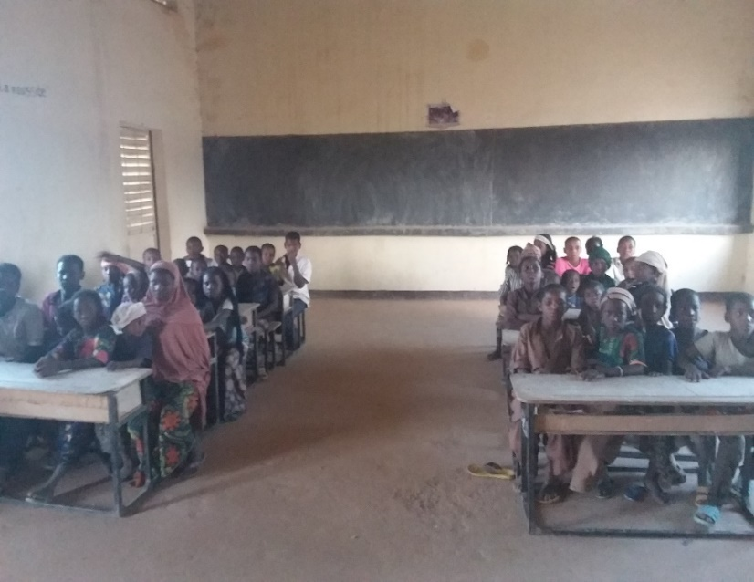

**School of Intatolène, pupils in the classroom**

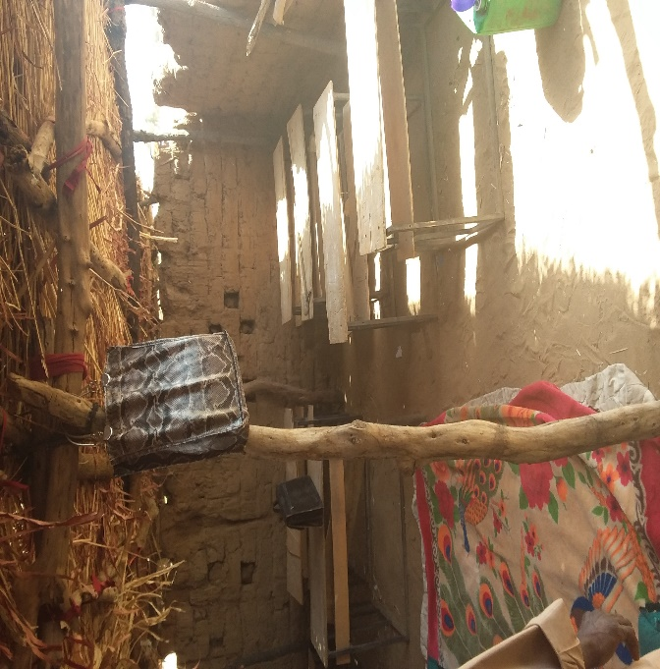

**School of Changhorane**

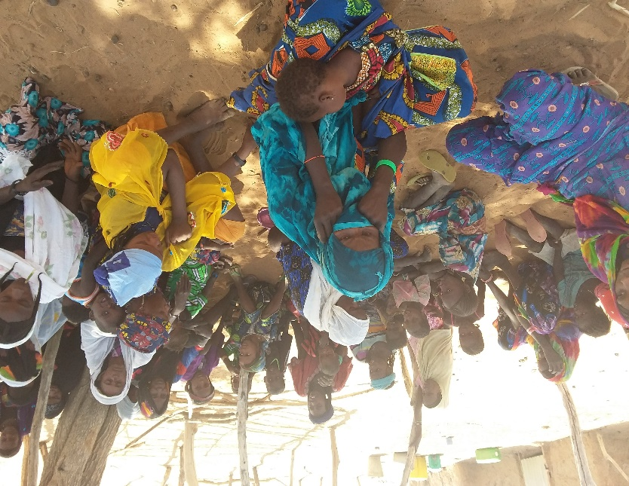

**Members of the goat cheese cooperative, Intatolène**

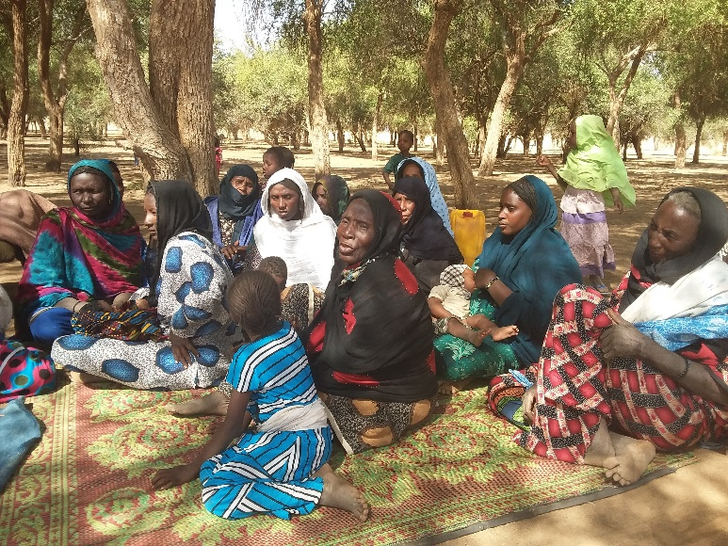

**Beneficiaries of microcredits, Changhorane**

ANNEX 6: Terms of Reference

**Terms of Reference FOR THE PROJECT FINAL EVALUATION**

**Comic Relief: «Supporting community schools for slave children in Niger»**

###### > Niamey, August 2017 <

1. **PROJECT BACKGROUND**

Niger is one of the poorest countries in the world, severely affected by climate change and chronic shortages of water and food. The situation has worsened as a result of recent events in neighbouring countries, including Libya and Mali.

Descent-based slavery (estimated to affect nearly 40,000 people in Niger) is still practiced in isolated areas of northern Niger. Those who emerge from slavery and their descendants are faced with widespread discrimination and have very limited access to sustainable livelihoods and public services. Most of the children of slave descent in this area do not have access to education because of the lack of schools in these areas and the discriminatory attitudes of the traditional authorities towards communities of slave descent. This leads to widespread under-investment in these regions. Local slave-owners often force these communities to work for free for them. These difficulties are compounded by the semi-nomadic way of life. Child labour is therefore the norm, and girls are very often victims of early marriage (86% of girls in rural areas in Niger marry before the age of 18).

Slavery was criminalized in 2003 but the law is not adequately enforced and there is no policy to address the specific needs of people of slave descent. The ongoing efforts of the anti-slavery movement, led by the prominent anti-slavery organization "Timidria", contributed to a better understanding of the problem by the public and the government, and the current President of Niger formally committed to the eradication of slavery, which creates a more favourable climate for intervention.

Since 2007, Anti-Slavery International has been working with Timidria for the eradication of slavery in Niger, through the education of children of slave descent in the department of Tchintabaraden (northern Niger). The initial community school program funded by Comic Relief (2007-2012) saw the creation of six (6) schools in villages formed by communities of slave descent. Throughout this program, 340 children of slave ancestry had access to quality primary education, achieving pass rates at the end of year examinations well above the national average. In addition to establishing schools, the program provided micro-credits to 150 mothers and carried-out awareness raising sessions on a variety of subjects, including slavery, early marriage, education and health, while facilitating contact between the communities and local, regional and national authorities. At the end of the program, lessons learned from the project (including the recommendations from the final evaluation and consultations with beneficiaries and project stakeholders) fed into the strategy of the second (2nd) phase of the Community Schools Program (2013 -2017).

In addition to continuing to support and expand the capacity of the six (6) community schools, the current programme focuses on:

• Intensify collaboration between the project and the government to promote the integration of community schools into the formal education system;

• Facilitate and support the transition of children to secondary school;

• Promote more investment by the State in villages formed by people of slave descent, especially with a view to creating new schools;

• Advocacy with multilateral agencies, development organizations and human rights mechanisms to ensure that descent based slavery is recognized as a priority;

• Conduct awareness-raising and advocacy trainings for communities to encourage their direct engagement with local and national authorities;

• Intensify efforts to promote child participation through peer support, mentoring and advocacy;

• Strengthen the links between the schools and the communities through Parents’ and Mothers’ Associations;

• Strengthen support for income-generating activities for women as a way to promote the economic independence of communities.

In parallel, from January 2014 to June 2016, Anti-Slavery and Timidria implemented an advocacy project funded by the European Commission, the aim of which was to encourage the State to invest more resources to guarantee access education and other basic social services in favour of communities of slave-descent from the Tahoua region. This 18-month project supplemented the advocacy efforts already undertaken under the Community Schools program.

In summary, the **overall objective** of the project is to **eradicate slavery in Niger by providing education to the present and future generations of children of slave descent.**

The specific outcomes of the program are:

1. More children of slave descent enjoy the right to quality primary education;
2. People of slave descent, including children, acquire the knowledge and skills to assert their rights;
3. Families have alternative livelihoods outside from slavery;
4. Local and national authorities are taking steps to address the needs of communities emerging from slavery.

**II. OBJECTIVES OF THE FINAL EVALUATION**

The purpose of this evaluation is to assess the extent to which the project objectives have been achieved, to document lessons learned, to review the changes that the project has brought about and to make recommendations for future projects. The final evaluation of the Comic Relief project should include these different areas of learning:

**What difference has the project made to people's lives (what, who, where, when)?**

*Essential questions:*

o To what degree have project outcomes been achieved? Were there any unexpected outcomes?

o Who has benefited (women, men, girls and boys) and in what ways?

o Are those changes (outcomes) relevant to people’s needs?

o Are they likely to be sustainable in the long term?

o Have there been changes to policies, practice and attitudes of decision and policy makers to benefit the project’s target groups? To what extent does the State now recognize the existence of communities of slave descent as a "distinct" group with specific needs? Give examples.

o To what extent has the project reduced the levels of exclusion and marginalization of members of the slave caste? (Perception of community members, perception of statutory and traditional authorities). Please give examples.

o Are there risks and / or concerns regarding the handing over of schools to the State (situation of school canteens, eg situation of teachers in the absence of bonuses etc.)? To what extent does the taking over of the schools by the State guarantee the sustainability of the community schools after the withdrawal of Timidria and Anti-Slavery International?

o To what extent has the achievement of the changes/ outcomes been influenced by external context and other factors?

o To what extent has the project contributed to the achievement of broader national and international policies, conventions, targets etc in the country/ies where the project is working?o What kind of actions/programmes would you recommend at the end of this project with a view to eradicating slavery practices in Niger?

***Desirable questions (if time and resources allow)***

o Is there a risk of a return to slavery or exploitative practices for the beneficiary communities or is the level of emancipation such that this risk is now minimal? Please give examples.

o To what extent has the project been effective in eliminating early marriage and forced labour?

o To what extent has the EU advocacy project benefited, hindered and learned from the Comic Relief-funded work and vice versa? Please provide examples.

o To what extent is the direct dialogue between communities and authorities sustainable? Can it do without the role of intermediary of Timidria? Are women included in direct advocacy with local and /or regional authorities?

o How do you explain that the State has not yet developed programs or policies that take into account their specific needs? What is the nature of the resistance (if any)? How can it be overcome?

o To what extent have the awards-raising activities carried out by the project with the neighbouring communities in the department of Tchintabaraden led to a rejection of slavery and discriminatory practices?

o How would you describe the situation in the surrounding communities (those who do not benefit from community schools and other support)? What is the nature of their relationship with traditional leaders, religious leaders and other dominant groups?

o How would you describe the situation of the three communities (Afalolo, Ineiss, Jigui Agoda) who benefited from new schools halfway through the project, thanks to their advocacy and that of Timidria? What is the nature of their relationship with traditional leaders, religious leaders and other dominant groups?

o To what extent did the project facilitate and support children's access to the college? What are the main challenges of access to and retention of children in secondary education?

o To what extent has the project increased awareness among international organizations (EU, UN Agencies, international NGOs) of the specific situation and needs of communities of slave descent? Please give examples.

**How has the project made this difference?**

**Approaches used by the project and implementing organisations:**

o What was the overall theory of change for this project? Has it been effective in bringing about lasting change? Were there any gaps?

o What have been the most effective methodologies and approaches the organisation used to bring about changes to people’s lives? What has worked and what has not? What lessons have been learned? Who have they been shared with?

o How has the type of organisations funded (e.g. user-led, social enterprise, national or international NGO), both UK and local, helped or hindered the delivery of lasting change?

o How have relations between partners (local and national offices in Timidria between them and with Anti-Slavery) helped or hindered the delivery of change / outcomes?

o Have there been external constraints (security, travel costs etc) and internal (organizational structure, interpersonal relations, salaries etc.) that hindered the implementation of the project? Which ones?

o Have the children targeted by the project participated in the design, development and implementation beyond the mere use of the services at their disposal? Did the Children's Councils allow children to participate effectively? Give examples.

o Have the target communities been involved in designing, developing and implementing the project beyond their participation in awareness-raising sessions and use of micro-credits?

o How effective have the project’s management and financial systems been (overall planning, estimating and budgeting, scheduling, coordination and communications, reporting, filing of receipts etc.)? How have they helped or hindered the delivery of lasting change?

o How effective have the project monitoring, learning and evaluation systems been (including the validity and reliability of data collection, quality of data, storage and analysis, data protection, effectiveness of processes to use and sharing of information)? How have they helped or hindered the delivery of lasting change?

o Has the project been cost effective? In what ways has the project provided value for money?

o What are the main lessons learned from this project?

**Approaches used by Comic Relief:**

o How have Comic Relief’s grant making policies and processes (e.g. how we define our programme strategies and outcomes, how we assess applications) helped or hindered the delivery of lasting change?

o How has Comic Relief’s approach to grant management (e.g. individual work with grant holders, and learning activities with other funded organisations) helped or hindered the delivery of lasting change?

o How has the way Comic Relief used its organisational assets helped or hindered the delivery of change (e.g. use of the media, access to decision makers)?

o Are there any other ways in which Comic Relief has helped or hindered the delivery of change?

1. **METHODOLOGY AND SCHEDULE OF THE FINAL EVALUATION**

The methodology consists of various activities: initial examination of documents, meetings with Timidria and phone interviews with Anti-Slavery International and Comic Relief; review and analysis of documents; development of evaluation tools and methodologies. This will be followed by a visit to the community schools in October 2017, which will include interviews with project beneficiaries and key stakeholders.

***3.1. Review of documents***

The following types of documents will be considered:

• Approved project proposal documents;

• Annual project reports and selected quarterly reports;

• Other evidence or impact document deemed important by the project team;

• Any important information about changes in the program, whether at the decision, strategic or implementation level.

• Any correspondence deemed relevant between Anti-Slavery International and its partners.

***3.2. Interviews***

• Interviews with Timidria, and phone interviews with Anti-Slavery International and Comic Relief before visiting the schools;

• Interviews with the Ministry of Primary Education and in particular, the school canteens division;

• Interviews with active education coalitions such as ASO/EPT Niger and CaCoPeD, what contributions to universal schooling and other educational opportunities have been made to achieve the MDGs to which Niger has subscribed;

• Interviews with international bodies or institutions such as Plan Niger, WFP, Oxfam.

• Semi-structured questionnaires will be developed by the evaluator in consultation with Timidria and Anti-Slavery International;

• Interviews with beneficiaries and programme stakeholders in the region where the project is implemented, ie children enrolled in community schools (3 out of the 6 initial schools as well as 2 newly created schools), secondary school students in the secondary school of Tchintabaraden and other secondary education structure, teachers, parents, representatives of Parents' Associations and Mothers’ Associations, members of the Children’s Councils, community members, educational, administrative and communal authorities at the local and regional levels as well as customary and religious authorities;

• The evaluator will visit three (3) beneficiary communities as well as two (2) news schools, all located in the department of Tchintabaraden, north of the Tahoua region.

***3.3. Confidentiality***

The evaluator will fully respect the confidentiality of the information collected, if requested by the interviewees. He / she may wish to have project staff attend to facilitate discussions, make respondents comfortable, and allow the evaluator to observe the interaction between Timidria staff and respondents.

***3.4. Other ethical aspects***

The evaluation should respect the principles contained in Anti-Slavery International's child protection policy. Prior to the field visit, the evaluator should familiarize himself / herself with this policy and commit in writing to respect the principles and follow the codes of conduct established in the policy. The evaluator shall avoid any conduct likely to harm the project, the participants or the staff. Nevertheless, if any abusive practice is identified, it will be brought to Anti-Slavery International's attention immediately, in accordance with the procedure set out in the child protection policy. Every effort will be made to make respondents feel comfortable, but it is true that some people (especially children) often distrust people they do not know and hesitate to express themselves freely. These difficulties will be taken into account in the analysis of data and interviews.

1. **CALENDAR**

The draft timetable for the final evaluation and the allocation of the evaluator's days are as follows:

|  |  |  |  |  |
| --- | --- | --- | --- | --- |
| Task | Number of days | Sept | Oct | Nov |
| Preliminary work (review of documents, meeting with Timidria, design of questionnaires etc.) | 6 | 6 |  |  |
| Travel to Niger – Visit to the schools (y including transports and interviews), meetings with beneficiaries and stakeholders | 16 |  | 16 |  |
| Writing and sharing of draft report with Timidria and Anti-Slavery International | 4 |  | 4 |  |
| Writing of final report and submission to Comic Relief | 3 |  |  | 3 |
| Total number of days | 29 |  |  |  |

1. **EXPECTED RESULTS**

The initial findings and draft report will be prepared and forwarded to Timidria and Anti-Slavery International for feedback. The report will be finalized and forwarded to Comic Relief in November 2017. The report has to be written in French. It should be clear and simply written, free of jargon. The main body of the report should not exceed 30 pages and should include an executive summary and recommendations. Technical details should be confined to appendices, which should also include a list of informants and the evaluation team’s work schedule. Background information should only be included when it is directly relevant to the report’s analysis and conclusions.

The report’s authors should support their analysis of a project’s achievements with relevant data and state how this has been sourced. Recommendations should also include details as to how they might be implemented.

We expect the report to include guidance on the process by which findings will be shared and discussed with all stakeholders including those who are benefiting from the project and how any resulting changes in the report will be included.

1. **MANAGEMENT AND SUPPORT**

Timidria will provide logistical support, including travel for the evaluator in Tahoua and community schools in Tchintabaraden (for example, renting a vehicle, hotel rooms in Tchintabaraden, payment of per diems). Timidria will accompany the consultant in the communities of Tchintabaraden and organize meetings with the main stakeholders of the project in Niamey, Tahoua and Tchintabaraden at the request of the evaluator.

1. **BUDGET**

The total budget for the evaluation is £11,050. The evaluator's fee is £200 per day (£200x29=£5,800). The rest is split between regional flights (£450), transport costs to Niamey (£745), accommodation in Niamey (£390), per diem for 16 days (£ 20 x 16 days = £ 320), accommodation in Tahoua and Tchintabaraden (£556), printing and photocopying costs (£90), translation costs (£267), etc. The flights (if needed) will be booked by Anti-Slavery International and the mission logistics in the country will be taken care of by Timidria.

1. **QUALIFICATIONS AND EXPERIENCE REQUIRED FROM THE CONSULTANT**

Open to national and sub-regional consultants/assessment offices, this final evaluation requires the following qualities and strengths:

**8.1. Essential**

• The consultant must be independent of all project partners and of Comic Relief;

• Demonstrable experience of carrying out high-quality, credible human rights evaluations;

• Excellent command of French, both written and oral;

• Speaking Tamasheq is an asset; if necessary, the consultant is assisted by a Tuareg translator who speaks Tamasheq perfectly.

• Speaking English is an asset for communicating with the donor Comic Relief.

**8.2. Desirable:**

• Experience working with vulnerable populations.

The consultant must be available between September, October and November 2017, during which the final evaluation is scheduled.

1. **HOW TO APPLY?**

Applicants should submit a CV, cover letter and a brief approach paper outlining ideas for the evaluation to Emmanuelle Tremeau, Africa Programme Officer, Anti-Slavery International at [e.tremeau@antislavery.org](mailto:e.tremeau@antislavery.org).

The deadline for applications is midnight on September 29th, with interviews to be held the week of October 2nd in Niamey, London or on Skype.

1. Source.
2. Parents or teachers have given their consent prior to any interview with the children.
3. Information saturation is observed when the answers of the interviewees or the various documents consulted become redundant, i. e. the same answers come back in the course of interviews and/or documents.
4. Intalotène school Director.
5. Source Annual Report, year 4.
6. Ibid.
7. Calculated using the ratio between the total cost of the project and the number of direct and/or indirect beneficiaries (members of households) of slave descent.
8. State-run canteens are classified into three groups: notably PAEQs are the most prestigious because they offer 3 meals a day to students and are rarely out of supply because they benefit from World Bank support. In the second group are the canteens supported by the World Food Programme (WFP), and in the third, those run by the State.
9. A term used by many of those interviewed from communities of slave descent.
10. ASI.
11. ASI.